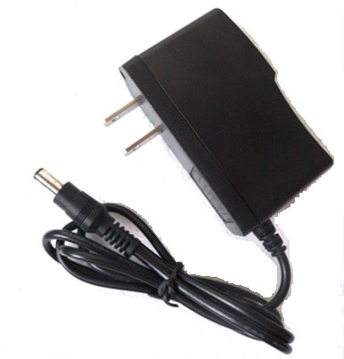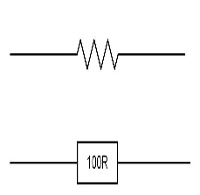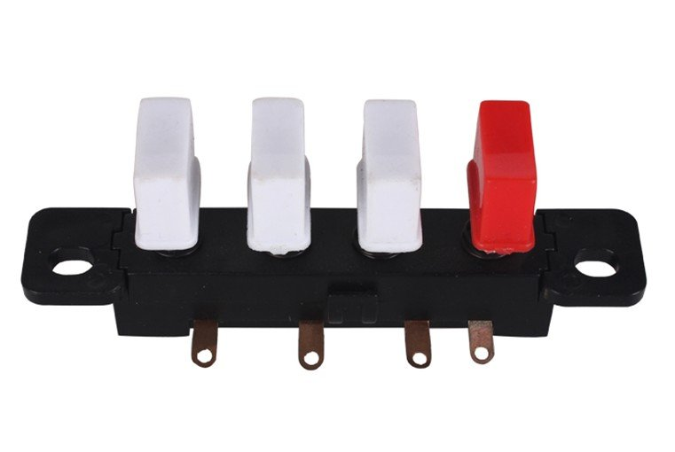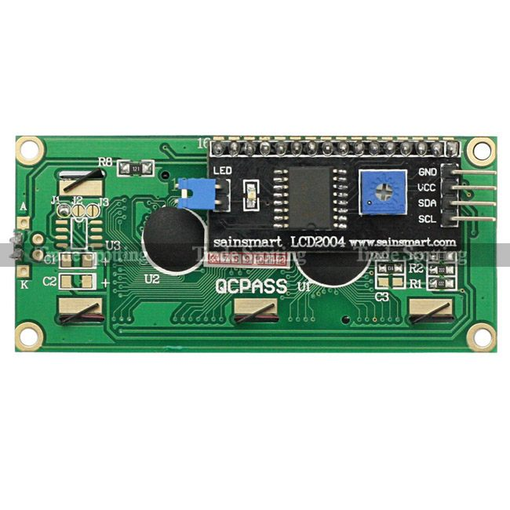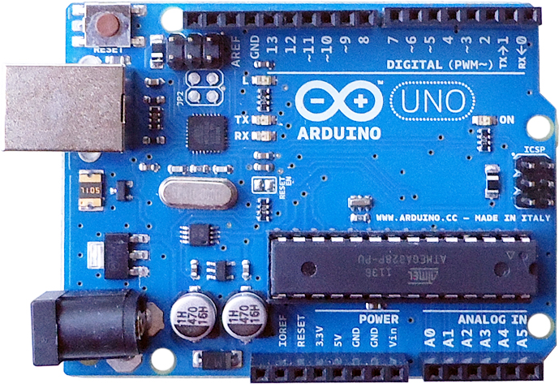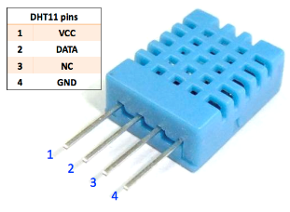V

Relay1

Relay2

Relay3

NC

NO

C

NC

To Page 2

DHT11 PIN 2 >> Pin 2 (UNO R3)

IN3 >> PIN7 (UNO R3)

IN2 >> PIN6 (UNO R3)

IN1 >> PIN5 (UNO R3)

**DHT11**

**Arduino UNO R3**

**LCD1602 + I2C**

**Adapter 9V 1A**

Button1 >> A0 (UNO R3)

Button2 >> A1 (UNO R3)

Button3 >> A2 (UNO R3)

R10K

R10K

R10K

GND >> GND  
VCC >> +5V

GND >> GND  
VCC >> +5V

SDA >> A4 (UNO R3)

SCL >> A5 (UNO R3)

GND >> GND  
VCC >> +5V

DHT11 PIN 1 >> +5V  
DHT11 PIN 4 >> GND

NO

C

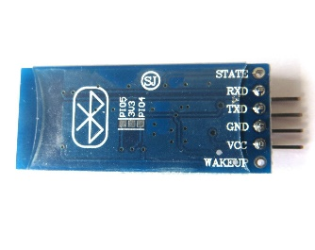

C

NC

NO

**HC-06 Bluetooth Module**

GND

VCC>> +5V  
GND>>GND

IN2

IN1

VCC

IN3

**Relay 3 Channel**

**Button of Fan**

L (220V)

**Relay 3 Channel**

Relay1

Relay2

Relay3

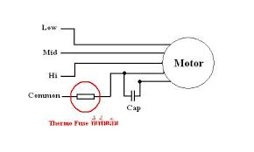

Number 1

Number 2

**Motor of Fan**

From Page 1

Number 3

Common